Day17 Revisit

AWS RDS – Amazon Web Service – Relational Database Service (Oralce/MySQL/Postgres/MariaDB/AmazonDB)

Free – Tier . Connected it using Dbeaver (GUI Tool which is written using JAVA)

Local Instance – Installing Locally (Download & Install postgres/MySQL and configure it)

Cloud Instance – Deployed in AWS RDS (Managed Automatically – Autobackup, AutoUpgrade, Monitoring the Performance, Load Balancing) – Enterprise level features

Database – Is a structured way of storing the data. It stores the data in the form of table. Table is nothing but collection of rows & columns.

RDBMS – Relational Database Management System (It’s application software which helps to store, retrieve, search, filter the data using a language called SQL)

SQL – Is the language of Database

SQL – Structured Query Language.

SQL Queries

1. DDL – Data Definition Language
2. DML – Data Manipulation Language
3. DCL – Data Control Language
4. TCL – Transaction Control Language
5. DQL – Data Query Language

Flat file vs DB Table

* Searching, filtering the data is challenging in flat file
* If the file size is big, handling it will be a challenge in flat file

Various popular SQL based Databases

1. Oracle (XE – Express Edition, Enterprise Edition, Community Version, MySQL)
2. MySQL (Open source Database)
3. MS-SQL (Microsoft SQL based RDBMS)
4. DB2 (IBM Database)
5. Postgres (Open Source Enterprise Level RDBMS)

Database is also Client – Server concept (Database Server)

Types of Server

1. Web Server (Used to perform web related activities)
2. Application Server (Used to perform enterprise activities)
3. Database Server (Used to perform database related activities)

In Database/RDBMS based application, We do following 4 operations (CRUD Operations)

C – Create (Create/Insert a new row or an entity) -- Insert query

R – Read (Reading one or all row from a table) - select query

U – Update (Updating either a single or multiple rows ) – update query

D – Delete (Deleting either one or more rows ) – delete query

Performing Database related activities

* Open MySQL Workbench

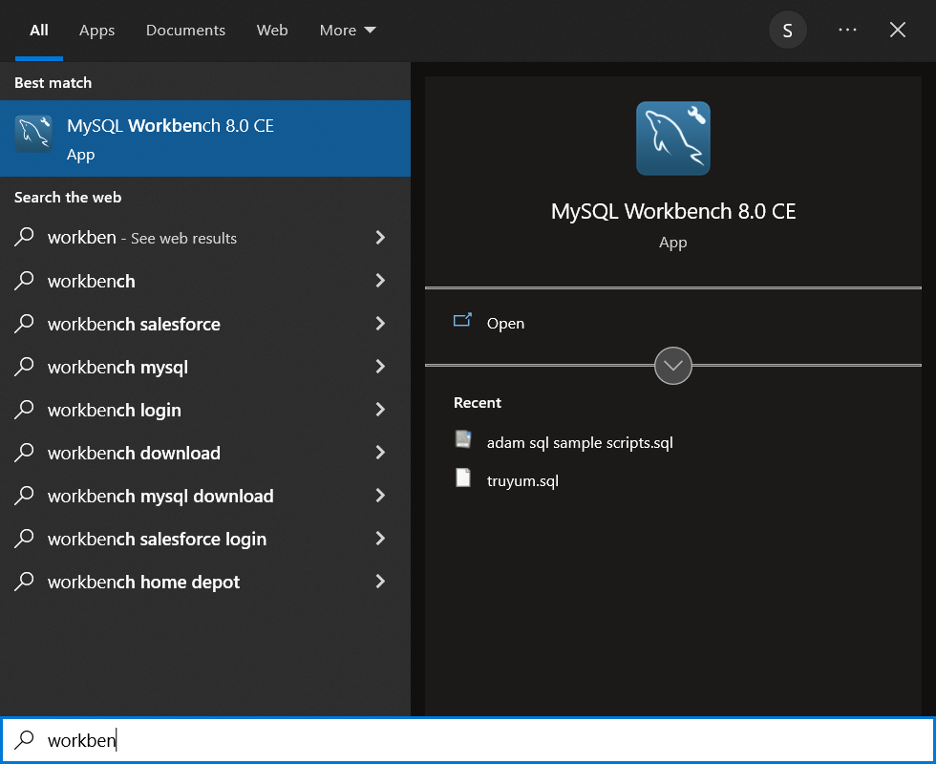

Different ways of connecting to Database server

1. Using command line client (CUI based app – Knowledge of SQL queries & DB commands are very important)
2. Using GUI (Graphical user Interface) – Workbench for MySQL, pgAdmin4 for postgres etc.,
3. Using any programming Language (C,C++, Java, Python, php, jsp etc.,)

Method 1 : Connecting to RDBMS (MySQL) Server using command line client.

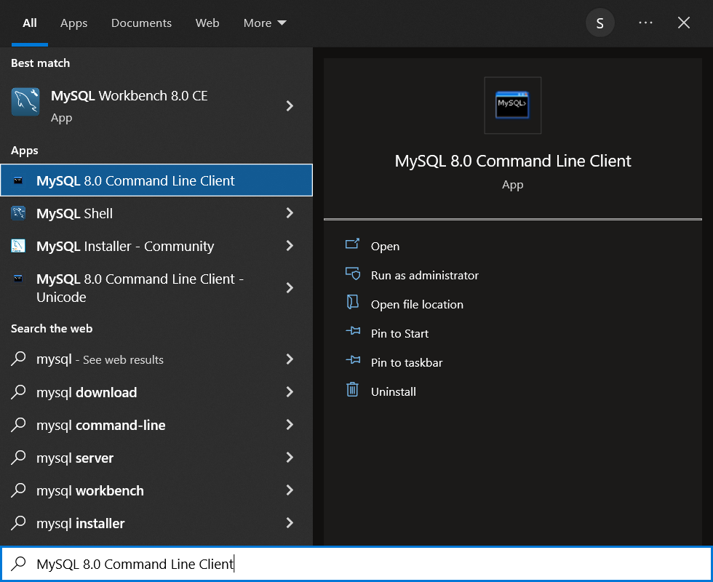

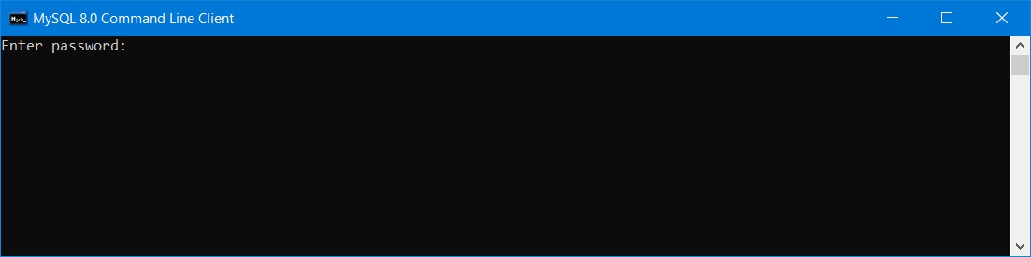

Here the password is “root”

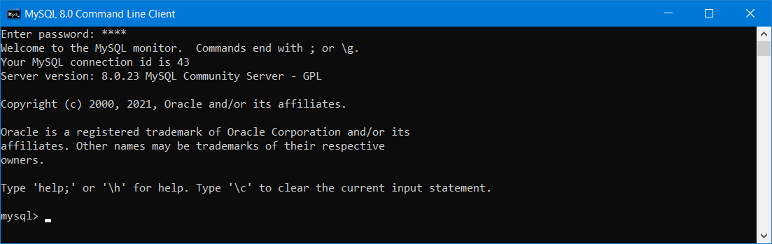

Some important CLI commands for MySQL

Show databases; -- Will display all the schema/database names available in your db server

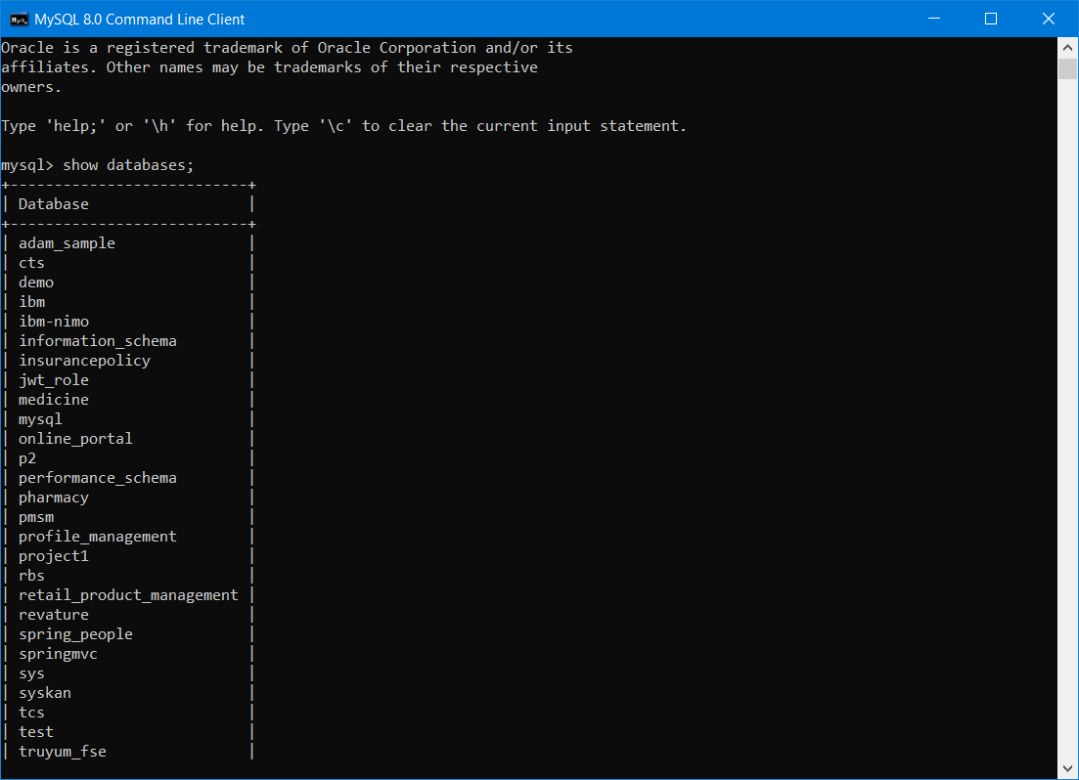

Use <db_name>; -- To select a particular database from the list of available database.

Use revature;

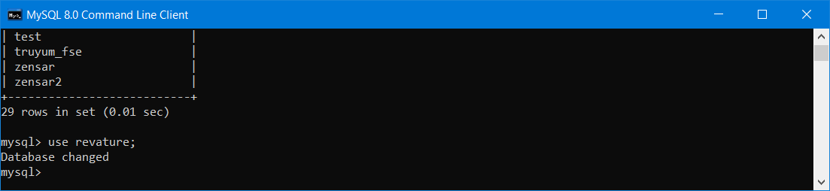

After selecting a database, to see all the tables available in that particular schema/database

Show tables; --- display all the tables available in that particular schema/database.

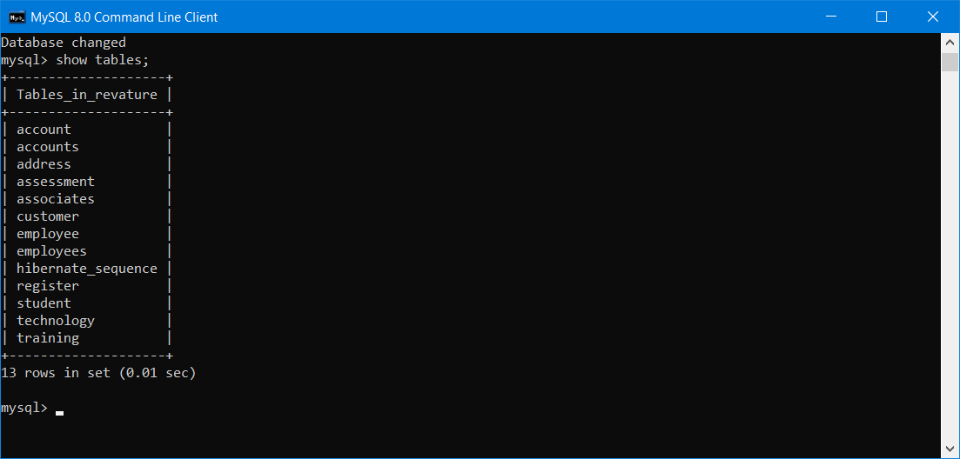

Selecting the contents of the table /displaying all the row (records) of the table.

Select * from <table_name>;

Select * from student;

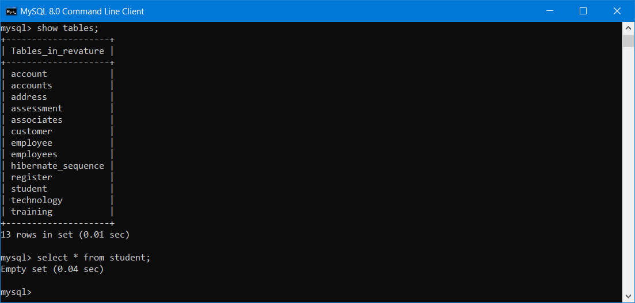

Select * from employee;

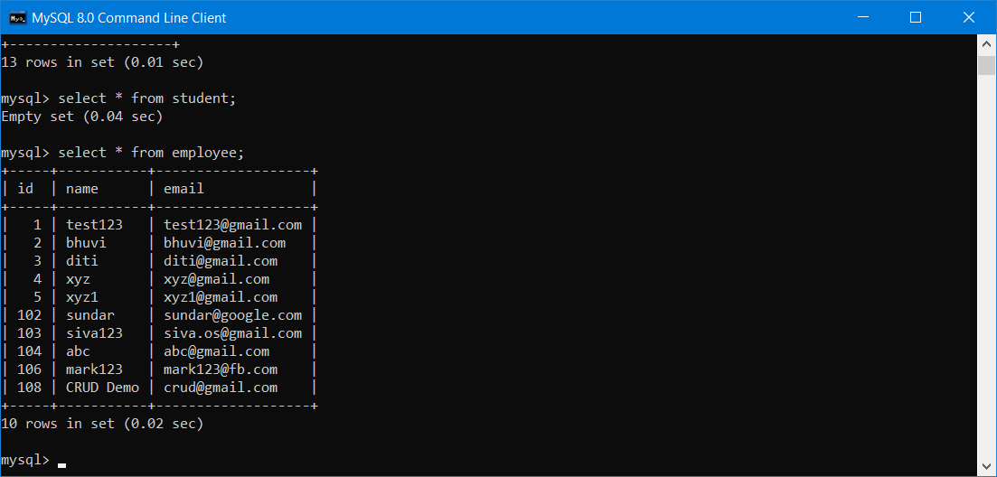

Insert query

Insert into <table_name> (column_names) values (?,..?);

Insert into employee (id,name,email) values (109, “insert”, “[insert@gmail.com](mailto:insert@gmail.com)”);

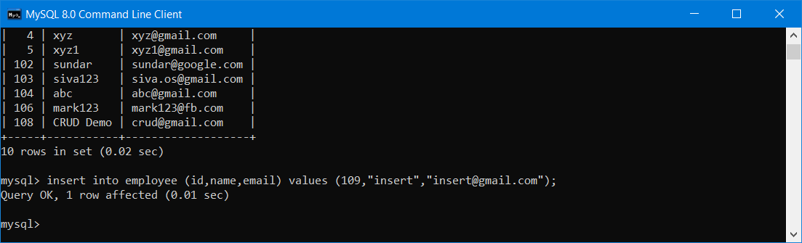

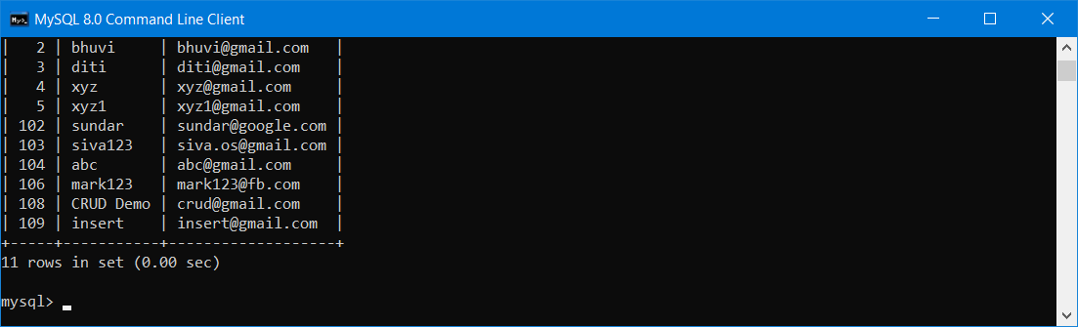

Update Operation

Update <table_name> set col_name1 =val1, col_name2=val2 …. Where pk_column=pk_val;

Update employee set name=”update”, email=”[update@gmail.com](mailto:update@gmail.com)” where id =109;

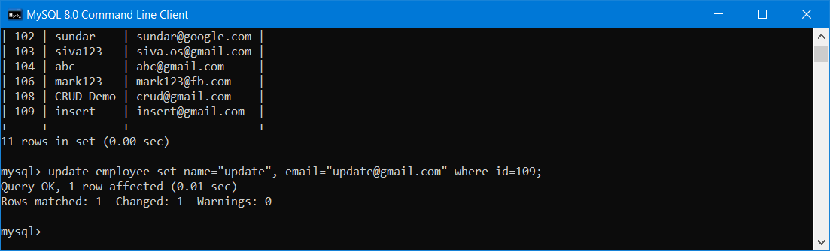

Delete operation

Delete from <table_name> where pk_col=Pk_Value;

Delete from employee where id=109;

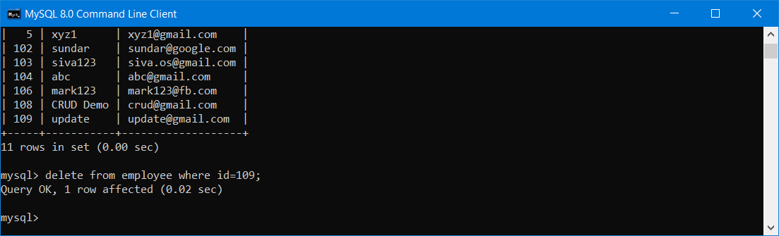

The sql commands are not case sensitive, but the table contents are case sensitive.

Method 2: Connecting to RDBMS using GUI Tools (Using Workbench for MySQL)

* Open Workbench

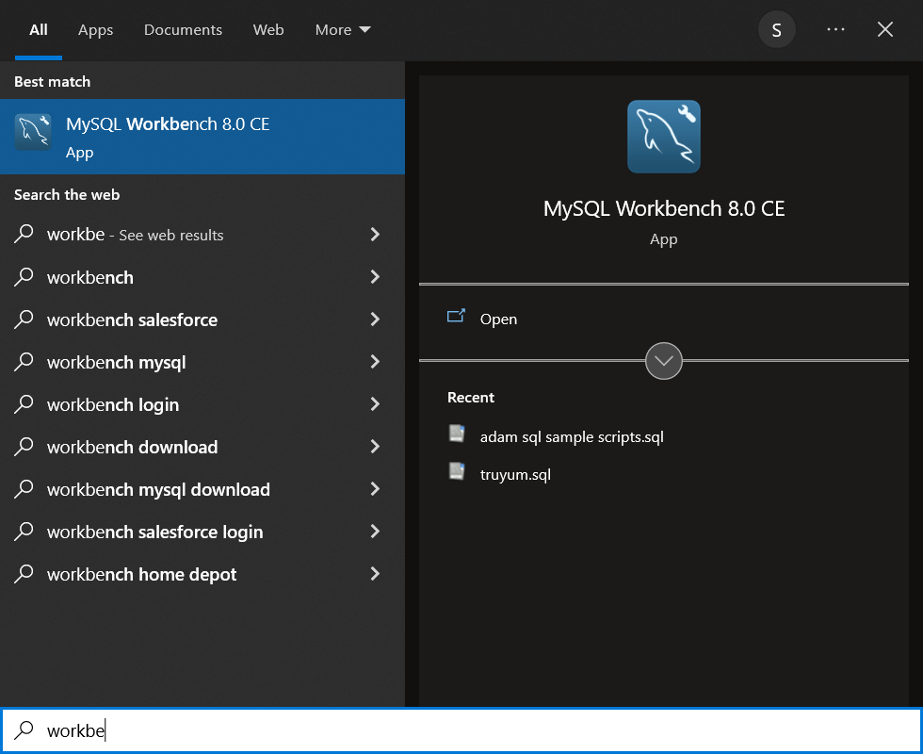

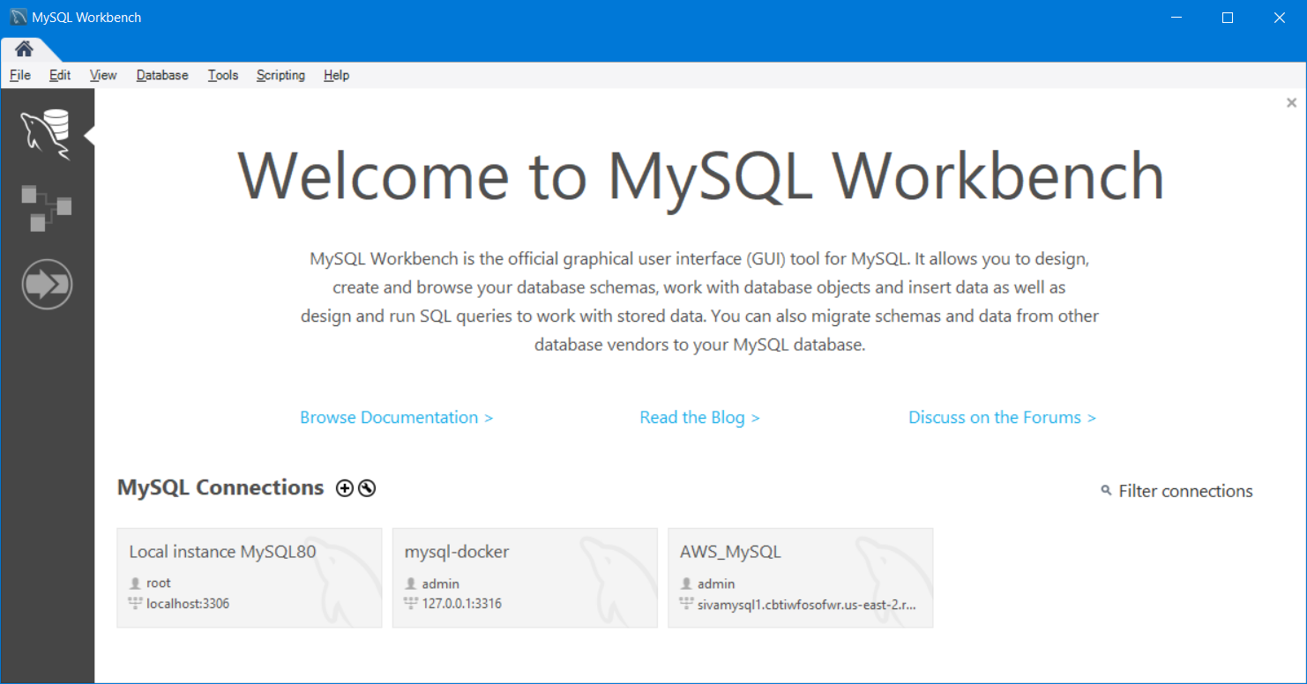

Click on the “Local Instance” – Downloaded & Installed Locally

This will open up MySQL workbench and display the administration tab by default.

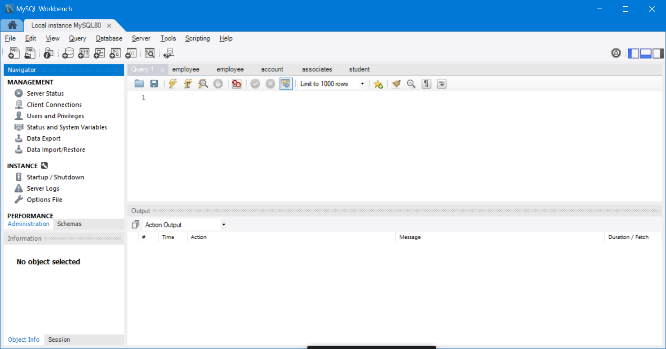

Click on the “Schemas” tab to see all the available databases/schema.

Double click a schema name to select that schema in workbench

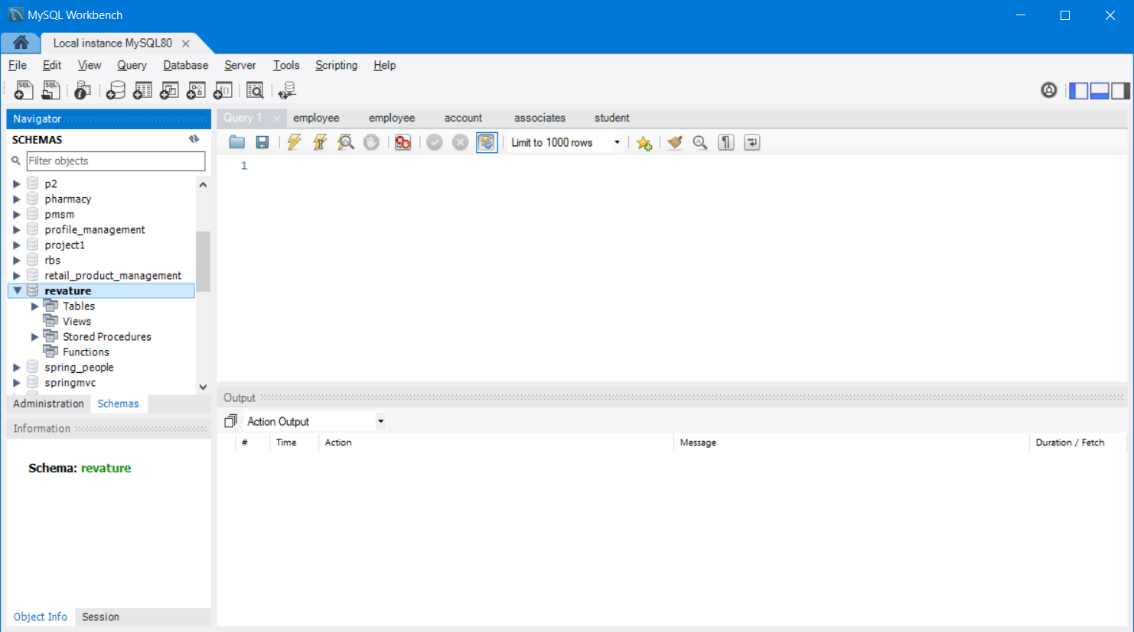

By clicking the drop down button (triangle button) we can see all available tables in that schema.

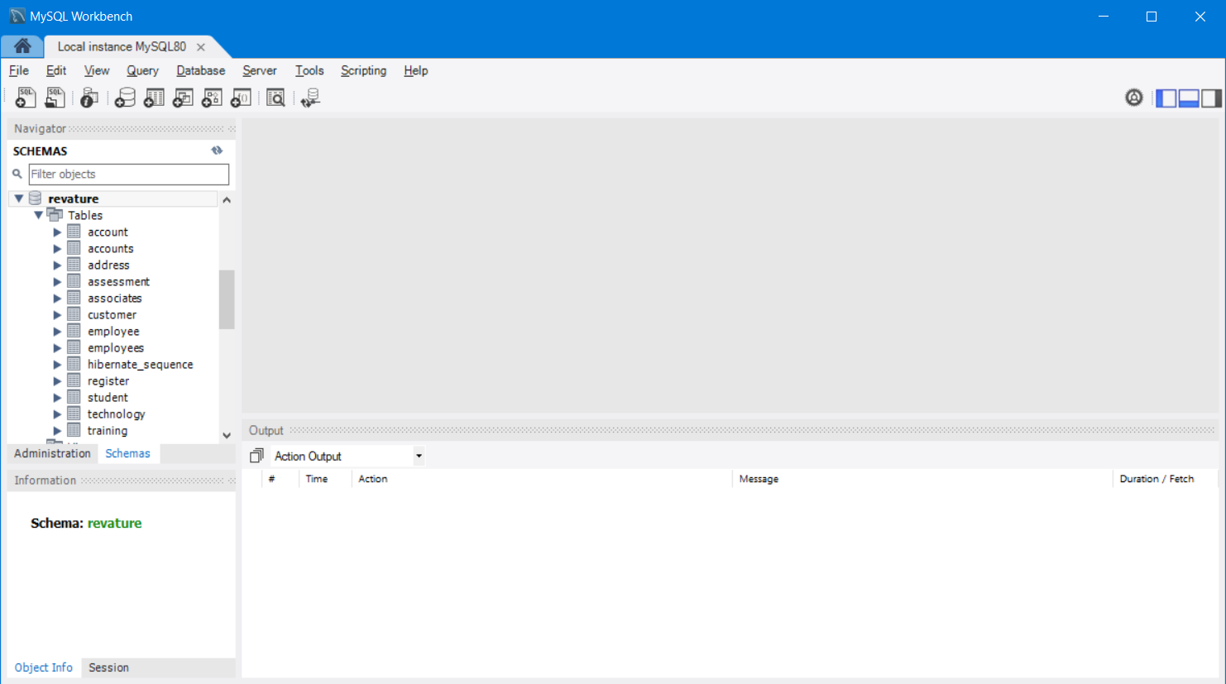

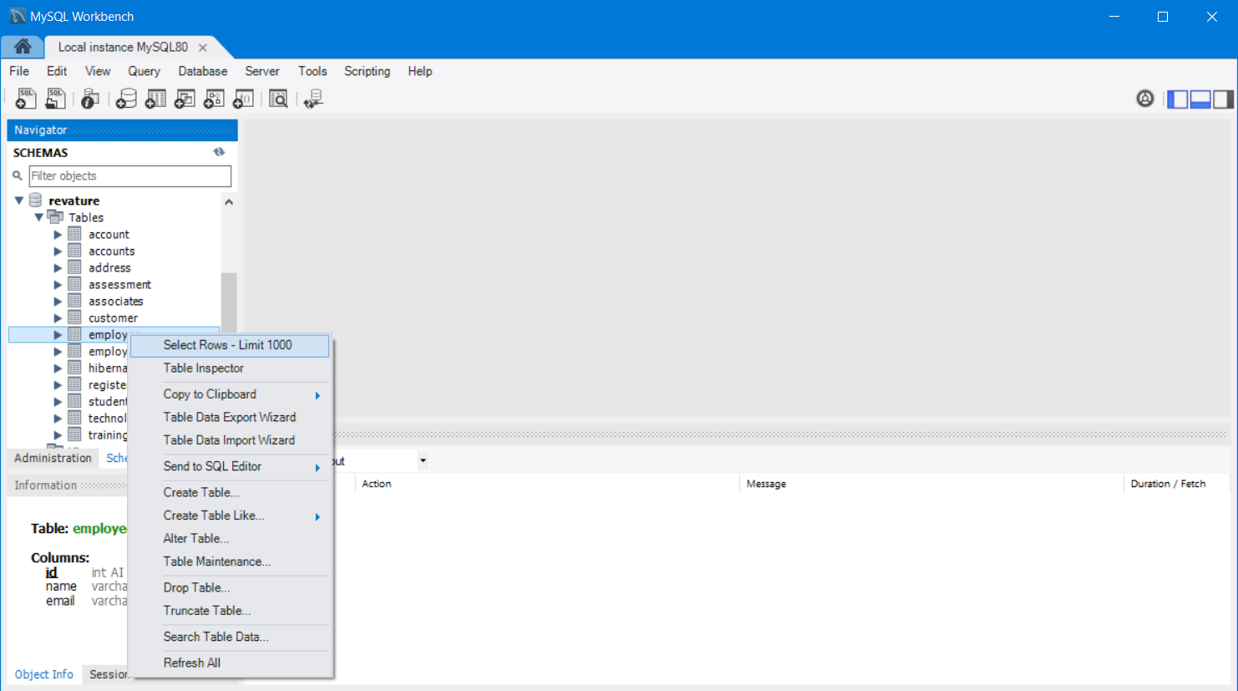

In database everything is an entity (table, query, view, sequence, trigger, functions, stored procedure)

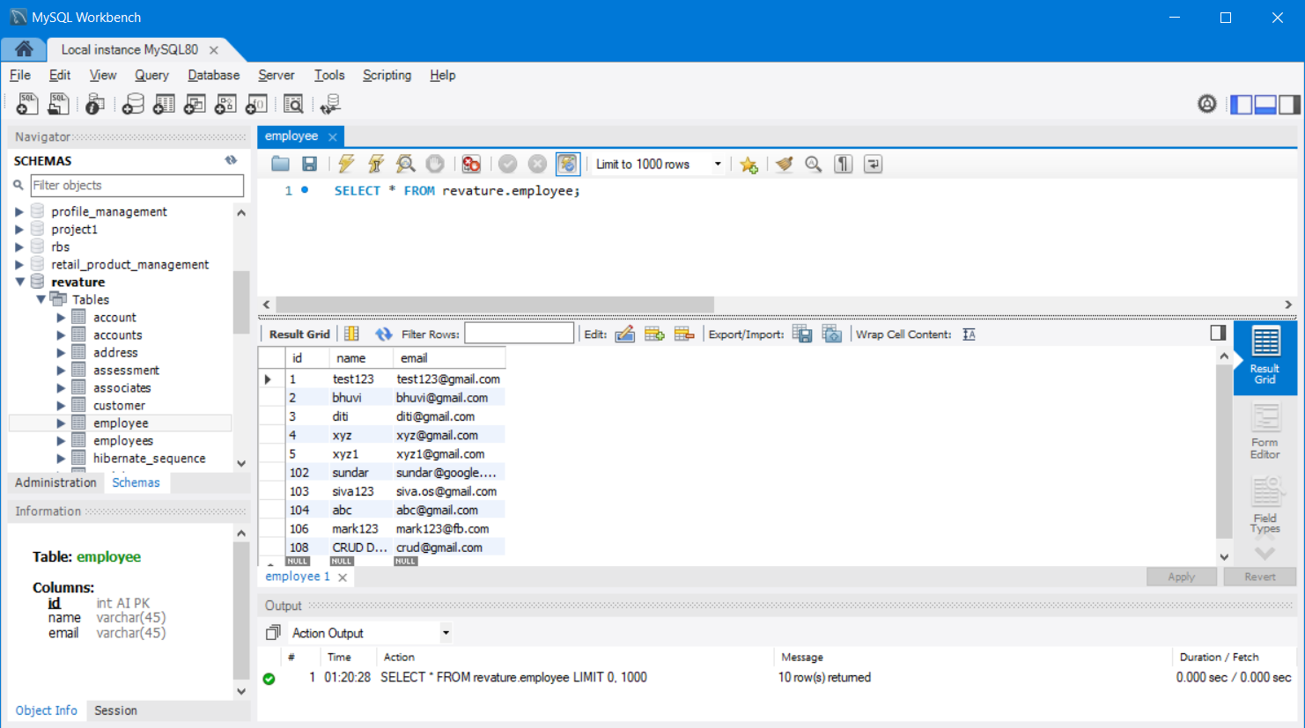

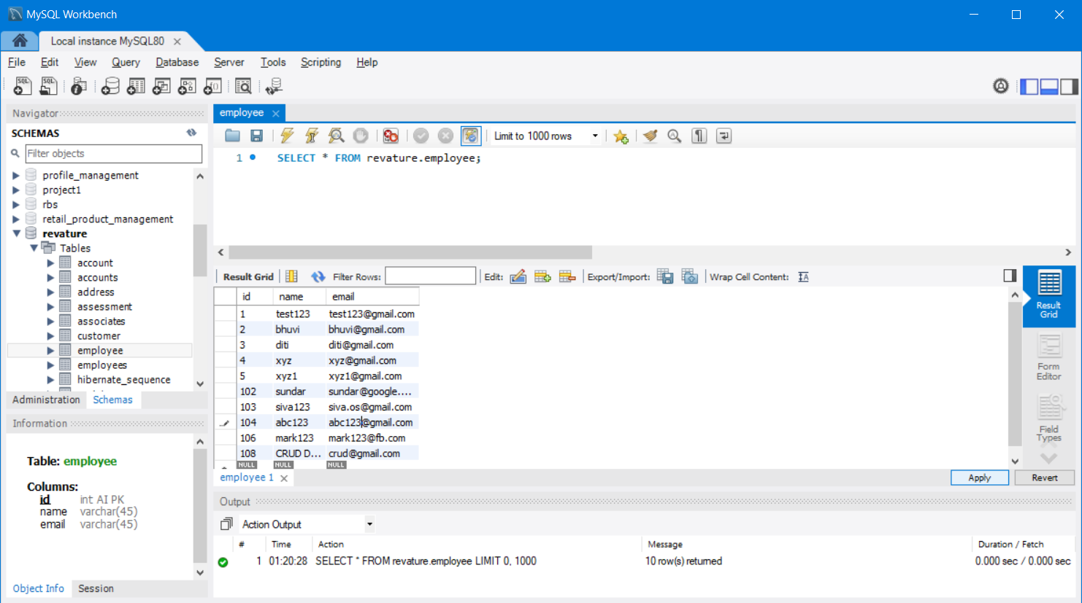

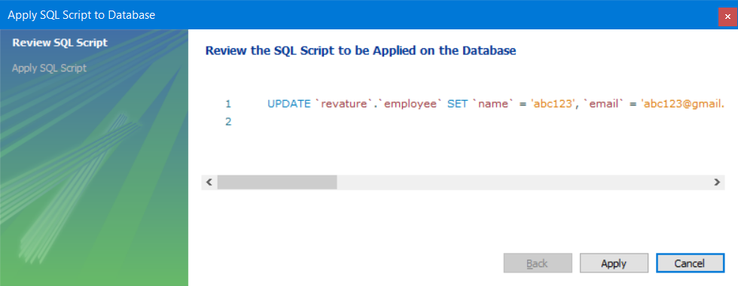

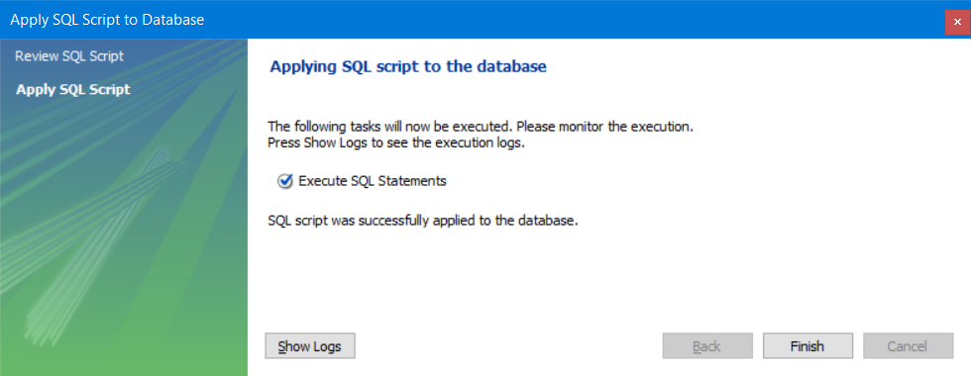

Creating insert query automatically using workbench

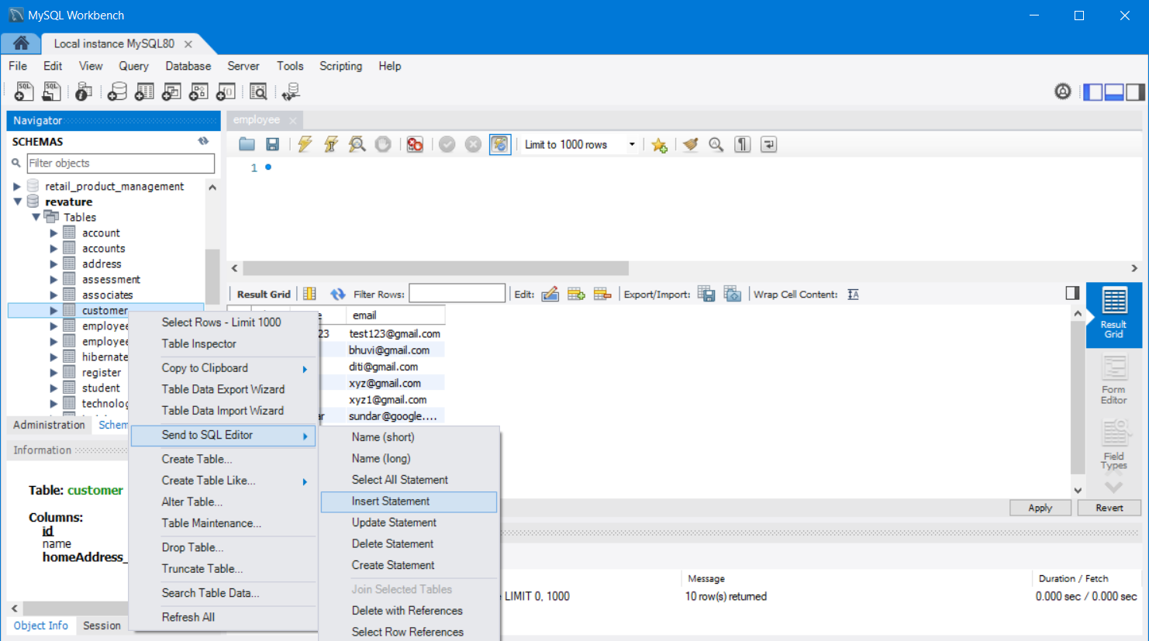

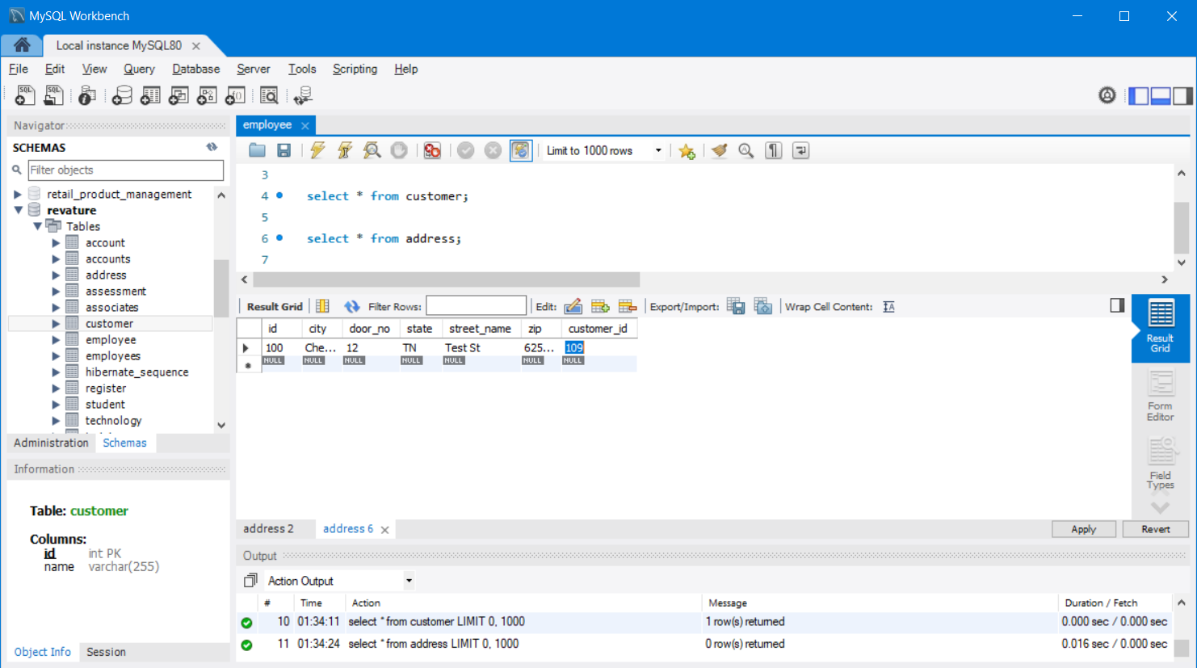

While connecting to the Database server, the following informations are needed

Database url jdbc:mysql://localhost:3306/revature (mysql)

jdbc:oracle:thin:@localhost:1521/XE (Oracle Express Edition)

jdbc:postgre://localhost:5432/postgres (postgres Open source database)

Address of the website/URL <https://www.gmail.com> (full url) short url : gmail.com

Connecting to MySQL using Dbeaver

* Open Dbeaver

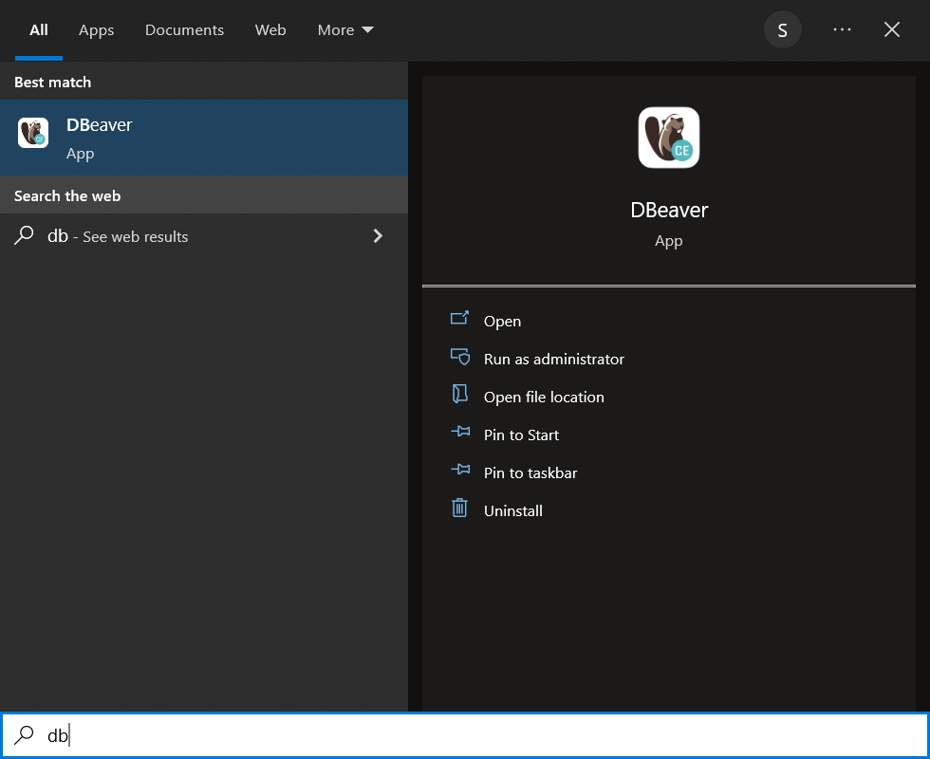

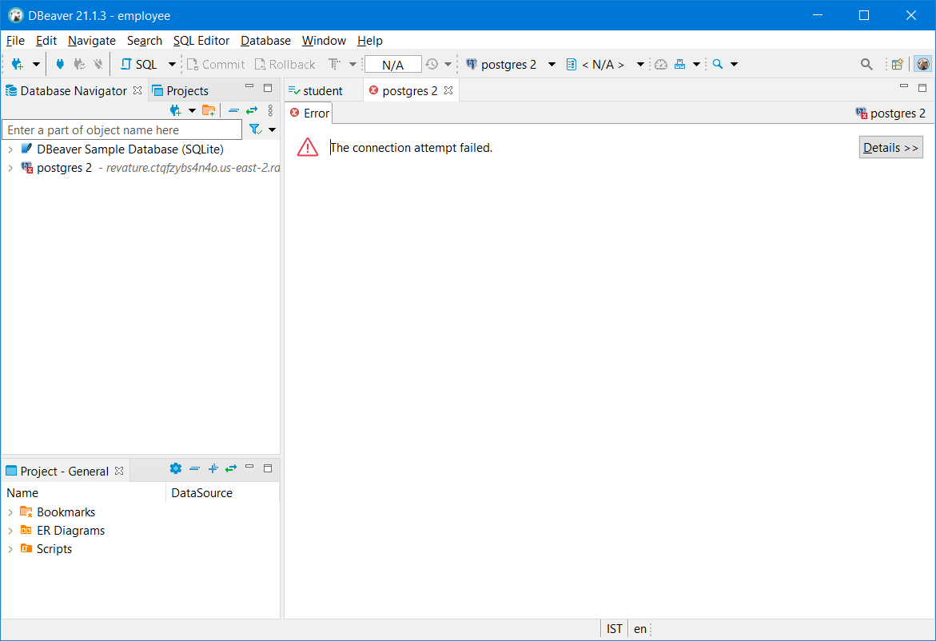

Click on Database 🡪 New Database Connection

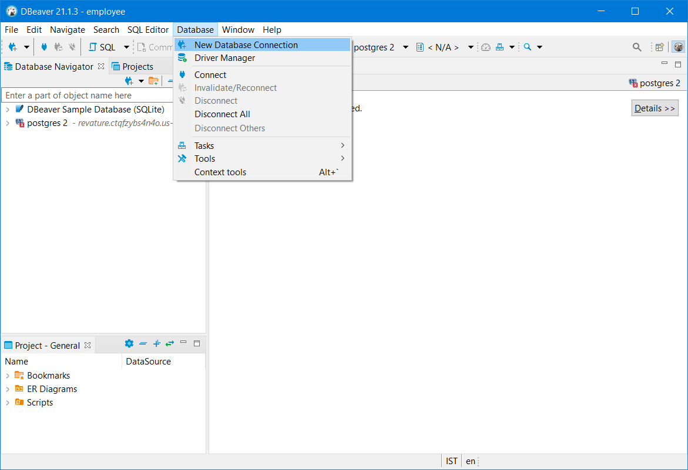

Select “MySQL” database in the below screen

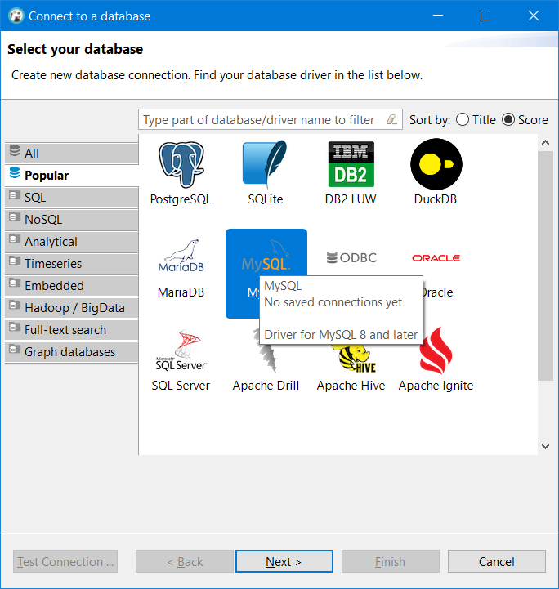

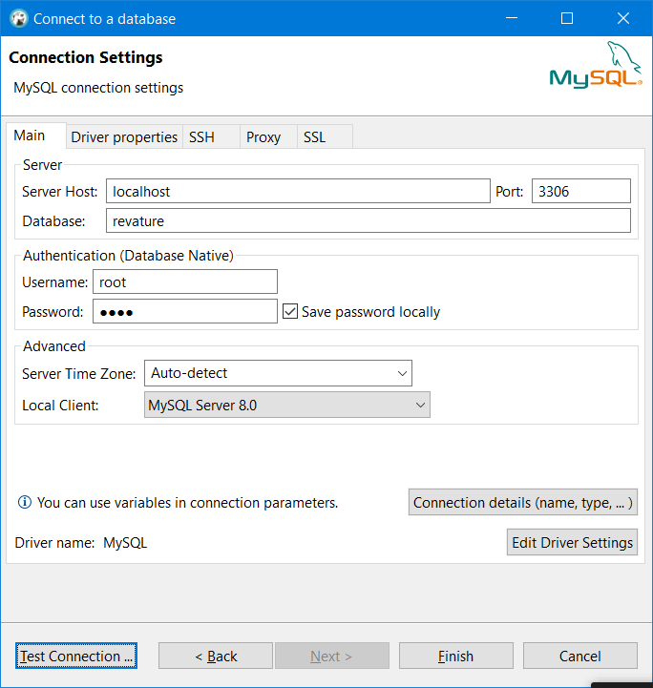

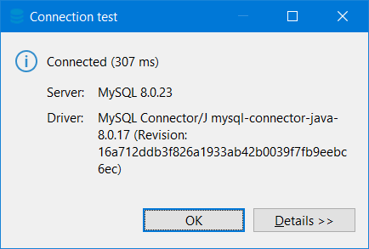

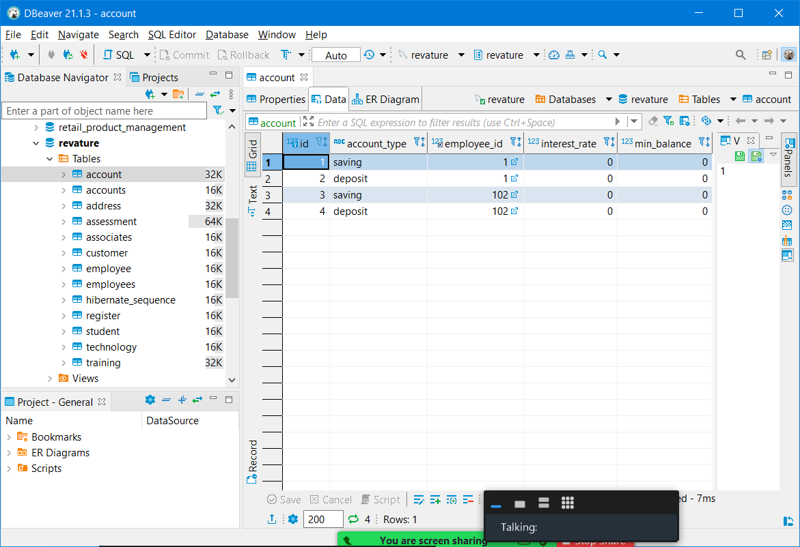

Types of SQL Language

1. DDL – Data Definition Language (To Define the entities) [No Rollback, changes are permanent]
   1. Create – To create an entity
   2. Truncate – To delete only the data and leave table structure as it is.
   3. Alter – To modify existing entity (Add/remove/rename a column, change it’s datatype or size)
   4. Drop – To delete existing entity along with the data. -Table structure won’t be available
2. DML – Data Manipulation Language (Used to Perform CRUD operation on Table)
   1. Create/Insert – To insert a new row (record)
   2. Update – To update existing row (record)
   3. Read/Select – To read single or multiple row (record)
   4. Delete – To delete single or multiple row
3. DQL – Data Query Language (Help to filter or sort the data)
   1. GROUP BY (making a group and performing few operations)
   2. ORDER BY (To sort the data based on a particular column)
   3. HAVING - SELECT NAME, COUNT(NAME) FROM STUDENT GROUP BY (NAME) HAVING COUNT(NAME) > 1;

Aggregate functions – count(),max(), min(), avg()

Scalar functions / row level functions (Perform operations on each row)

* TO_CHAR(DATE,'DATE_FORMAT')
* TO_DATE(DATE,'DATE_FORMAT')
* UPPER('VALUE')
* LOWER('VALUE')

Aggregate functions /Column level functions (Perform operation on column level)

* Max()
* Min()
* Avg()
* Count()

1. DCL – Data Control Language (Helps to control permission on the db entities)
   1. Grant (Used to provide some access permissions to users)
   2. Revoke (Used to revoke the provided access permission from users)
2. TCL – Transaction Control Language
   1. Commit
   2. Rollback
   3. Savepoint

Constraints – Unique, Not Null, Primary Key (Not Null & Unique) , Foreign Key (Restrict data insertion based on parent table content) , Check, Default, Auto Increment.

Constraints can be added to columns while defining the entities.

Making relationship between tables can be done using foreign key. (Referential integrity)

Relationship between tables

1. One to One ( 1..1) – Primary key (No duplicates , no null )
2. One to Many /Many to One (1..n or n..1) (foreign keys – duplicates are allowed)
3. Many to Many (m..n)

Normalization (It’s the process of optimizing the database entity)

* Avoids redundancy (remove duplicate entries)
* Improves data integrity and consistency

Different Normal Forms

1. 1NF (First Normal Form) - must have a primary key, no repeating groups, and atomic columns
2. 2NF (Second Normal Form) - must already be in 1NF, plus have no partial dependencies
3. 3NF (Third Normal Form) - must already be in 2NF, plus have no transitive dependencies
4. BCNF/3.5NF (Boyce-Codd Normal Form)
5. … 7NF